Problem Statement
Problem Statement: Mutual Fund FAQ Assistant (Facts-Only Q&A)
Overview
The objective of this project is to build a facts-only FAQ assistant for mutual fund schemes, using Groww as the reference product context. The assistant will answer objective, verifiable queries related to mutual funds by retrieving information exclusively from official public sources, such as AMC (Asset Management Company) websites, AMFI, and SEBI.
The system must strictly avoid providing investment advice, opinions, or recommendations. Every response must include a single, clear source link and adhere to defined constraints around clarity, accuracy, and compliance.

Objective
Design and implement a lightweight Retrieval-Augmented Generation (RAG)-based assistant that:
- Answers factual queries about mutual fund schemes
- Uses a curated corpus of official documents
- Provides concise, source-backed responses

Target Users
- Retail investors comparing mutual fund schemes
- Customer support and content teams handling repetitive mutual fund queries

Scope of Work
1. Corpus Definition
- Select one Asset Management Company (AMC)
- Choose 3–5 mutual fund schemes, ensuring category diversity (e.g., large-cap, flexi-cap, ELSS)
- Collect 15–25 official public URLs, including:
  - Scheme factsheets
  - KIM (Key Information Memorandum)
  - SID (Scheme Information Document)
  - AMC FAQ/help pages
  - AMFI/SEBI guidance pages
  - Statement and tax document download guides

2. FAQ Assistant Requirements
The assistant must:
- Answer facts-only queries, such as:
  - Expense ratio of a scheme
  - Exit load details
  - Minimum SIP amount
  - ELSS lock-in period
  - Riskometer classification
  - Benchmark index
  - Process to download statements or capital gains reports
- Ensure:
  - Each response is limited to a maximum of 3 sentences
  - Each response includes exactly one citation link
  - Each response includes a footer:
“Last updated from sources: <date>”

3. Refusal Handling
The assistant must refuse non-factual or advisory queries, such as:
- “Should I invest in this fund?”
- “Which fund is better?”
Refusal responses should:
- Be polite and clearly worded
- Reinforce the facts-only limitation
- Provide a relevant educational link (e.g., AMFI or SEBI resource)

4. User Interface (Minimal)
The solution should include a simple interface with:
- A welcome message
- Three example questions
- A visible disclaimer:
“Facts-only. No investment advice.”

Constraints
Data and Sources
- Use only official public sources (AMC, AMFI, SEBI)
- Do not use third-party blogs or aggregator websites
Privacy and Security
- Do not collect, store, or process:
  - PAN or Aadhaar numbers
  - Account numbers
  - OTPs
  - Email addresses or phone numbers
Content Restrictions
- No investment advice or recommendations
- No performance comparisons or return calculations
- For performance-related queries, provide a link to the official factsheet only
Transparency
- Responses must be short, factual, and verifiable
- Every answer must include a source link and last updated date

Expected Deliverables
- README Document
  - Setup instructions
  - Selected AMC and schemes
  - Architecture overview (RAG approach)
  - Known limitations
- Disclaimer Snippet
  - “Facts-only. No investment advice.”

Success Criteria
- Accurate retrieval of factual mutual fund information
- Strict adherence to facts-only responses
- Consistent inclusion of valid source citations
- Proper refusal of advisory queries
- Clean, minimal, and user-friendly interface

Summary
The goal is to build a trustworthy, transparent, and compliant mutual fund FAQ assistant that prioritizes accuracy over intelligence. The system should ensure that users receive only verified, source-backed financial information, without any advisory bias or speculative content.

Diagram FLOW
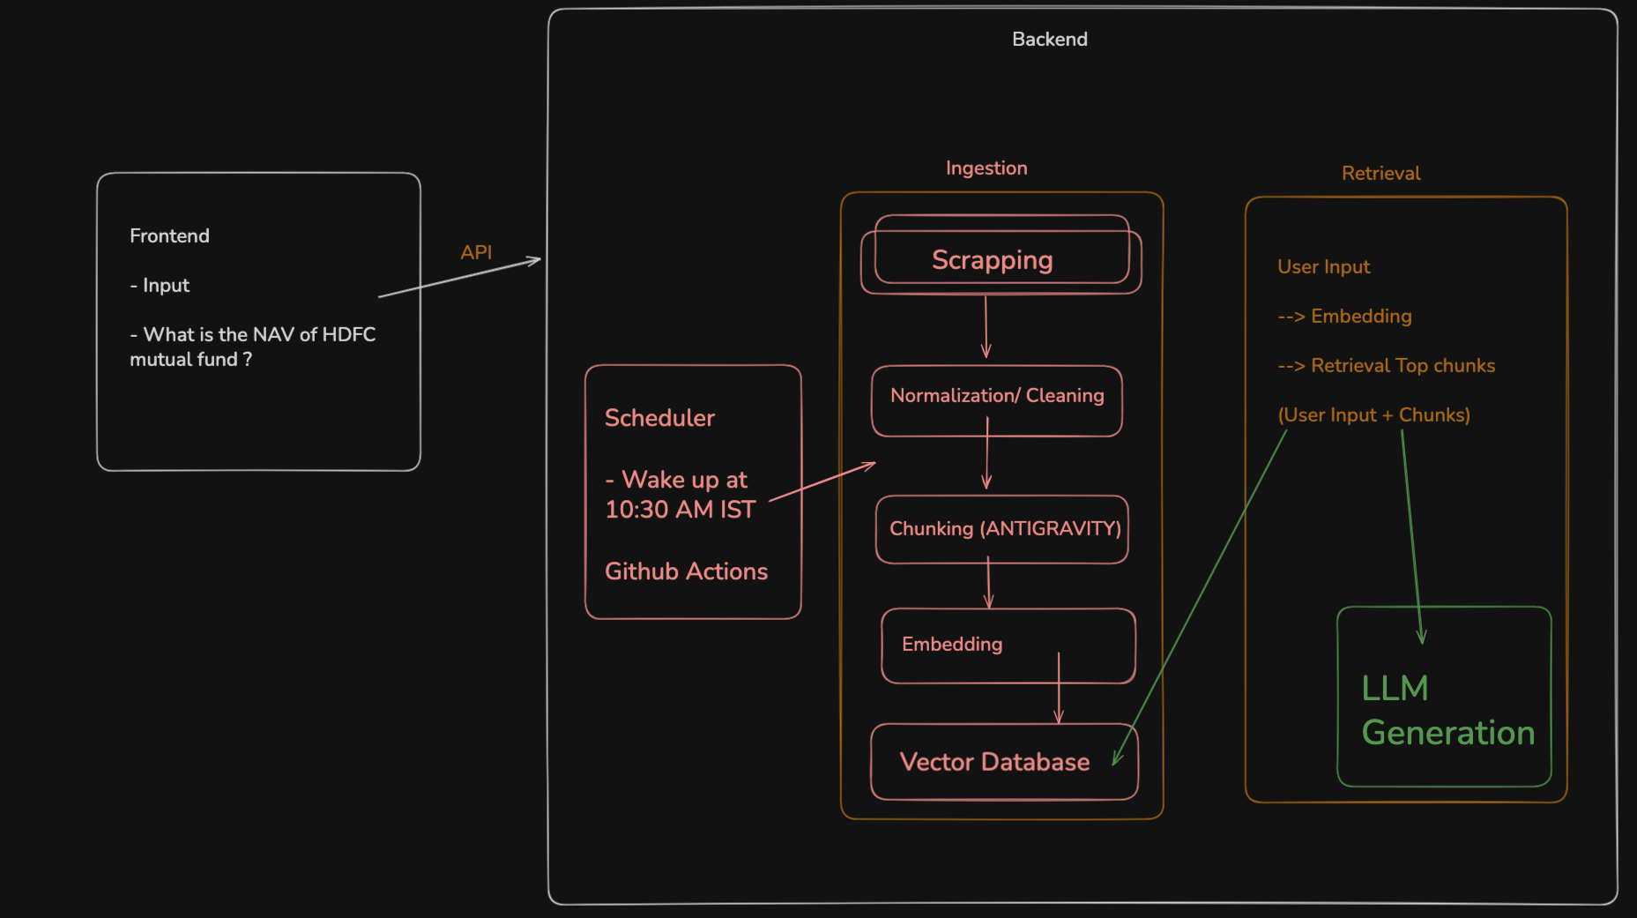

STEP
- CONTEXT
  - problemStatement.md → context.md
  - architecture.md
  - implementation.md
  - edge-case.md
  - eval.md

Prompt
- Generate an problemStatement.md file using @docs/problemStatement.txt which stores the necessary context of the project
- https://groww.in/mutual-funds/hdfc-gold-etf-fund-of-fund-direct-plan-growth https://groww.in/mutual-funds/hdfc-large-cap-fund-direct-growth https://groww.in/mutual-funds/hdfc-small-cap-fund-direct-growth https://groww.in/mutual-funds/hdfc-silver-etf-fof-direct-growth https://groww.in/mutual-funds/hdfc-mid-cap-fund-direct-growth
Currently for these stocks we will make the RAG chatbot so update in @docs/problemStatement.md
- Corpus Definition in @docs/problemStatement.md can also be updated as we have given URLs
- Generate an detailed Architecture.md for this @docs/problemStatement.md
- In @docs/Architecture.md in external sources only grow URLs which we gave will be there, there will be no PDFs and other sources
- Generate an phase-wise implementation plan as per the @docs/Architecture.md
- Update these in @docs/ImplementationPlan.md and @docs/Architecture.md
LLM used will be Groq
Embedding model will be BGE model rather than openAI model
- Generate edge-case.md for all corner scenarios using @docs/ImplementationPlan.md and @docs/Architecture.md
- Generate an eval.md for each phase for the @docs/ImplementationPlan.md
- Implement phase1.1 Document fetcher as per the @docs/ImplementationPlan.md
- Implement phase1.2 as per @docs/ImplementationPlan.md
- We can store the data into some files so that I can review the data for phase1.2 as well
- Understand the parsed data and then update chunking strategy for the RAG
Update the chunking strategy in @docs/ImplementationPlan.md which we used here
- Implement phase1.3 as per @docs/ImplementationPlan.md
- Based on the chunks update the embedding Strategy in the @docs/ImplementationPlan.md
Can we use the BGE small model for this data or large model we should use ?
- Implement phase 1.4 as per the @docs/ImplementationPlan.md
- Implement phase 1.5 as per the @docs/ImplementationPlan.md
- Write a basic script so that I can view embeddings for these chunks (VERIFY ALL THE EMBEDDINGs)
- Understand the embeddings and chunks then update the retrieval Strategy in the @docs/ImplementationPlan.md and then implement phase2
- In the phase3 of @docs/ImplementationPlan.md we can take care of the limits of groq
llama-3.3-70b-versatile
request per minute - 30
request per day - 1K
tokens per minute - 12K
tokens per day - 100K
- Implement phase3 as per the @docs/ImplementationPlan.md
- Implement phase4 as per the @docs/ImplementationPlan.md
- Implement phase5 as per the @docs/ImplementationPlan.md

AFTER BACKEND AND FRONTEND WE WILL INTEGRATE SCHEDULER COMPONENT
- After phase5
We want a scheduler component to trigger the ingestion component so that everyday we have the latest data, add an phase for scheduler component in the @docs/ImplementationPlan.md and architecture.md
- In Phase 6 we want the scheduler created with github actions so update the @docs/ImplementationPlan.md
- Implement phase6 as per the @docs/ImplementationPlan.md
- Implement phase6 as per the @docs/ImplementationPlan.md
We want the scheduler to run at 10:30 AM IST every day.

DEPLOYMENT
- Push the code changes to github

WE WILL GET THE SCHEDULED
You need to click on ACTIONS TAB → 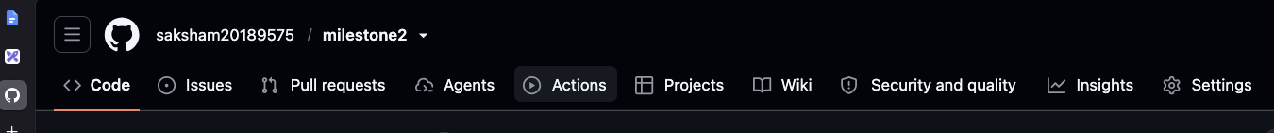

Option 1 → If your frontend (basic frontend) is on streamlit
Then BOTH Backend and Frontend → streamlit
https://share.streamlit.io/

Option 2 → If your frontend is React, vite, nextjs etc
Backend → RAILWAY
Frontend → VERCEL

